


University of Westminster

Advanced Client-Side Development
5COSC026C

-PORTFOLIO REPORT-

Muhammed Rizwan Ahamed Rizlan
Uow Number: W1987516
IIT Number: 20223256

Table of content

Table of content 2
Folder Structure 3
Project Timeline 4
Week 01 - 03/10/2024 4
Week 02 - 10/10/2024 5
Week 03 - 17/10/2024 6
Week 04 - 23/10/2024 7
HTML VALIDATION 7
CSS LINT 9
CODES 11
1. HTML FILES 11
index.HTML 11
virat-Kohli.HTML 20
haritha-Kanda.HTML 23
2. CSS FILES 27
style.css 27
SCREENSHOTS OF FINAL WEBSITE 45
1. DESKTOP VIEW 45
2. MOBILE VIEW 49

Folder Structure
The following Image represents my Project Structure, where HTML and CSS files are kept in the root folder
Where images are kept in a separate folder called Images which is inside the root folder, Index.html is my main page, and the other 2 pages for Blog posts

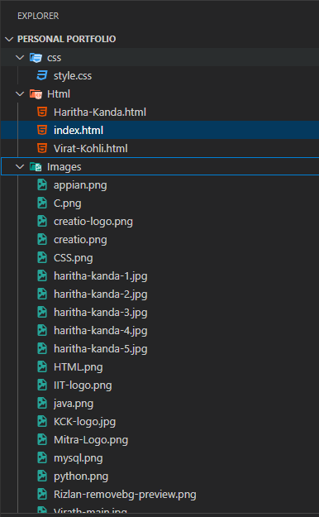

Project Timeline

Week 01 - 03/10/2024
Sketching the basic design and layout of the Portfolio
- Designed a basic Structure of the Home page, Navbar
- Start developing the File Structure
- Found image for the Introduction Picture
- Added social media icons and links
- Linked and imported related links like CSS / Google fonts and box icons
- Start Creating the home page on the index.html page using the semantic and non-semantic tags of HTML5
  - Header
  - nav
  - section
  - Div
  - p/h1/h2
  - Span
  - a
  - i
  - Image
- Created the CSS file named style.css
- Set margin, padding zero by default
- Mentioned the font family
- Pre-Assaign the main colors to variables so I can reuse it
- Added a linear-gradient background to the main image
- Add border radius for image
- Hover functions
- Boxshadows are used to highlight the element when hovered over
Completed the home and nav bar functionalities and designs with stylings
Since the homepage is the first thing people see, I want it to be straightforward but memorable. I’m thinking of putting a portrait of myself on one side so it feels personal right away, and then my name, profession, and interests on the other side with a little animation for flair. I’ll keep the navbar simple—a
logo on the left to link back to the homepage and links to the blog posts.

Week 02 - 10/10/2024
I started to create an animation for my roles, as per plan the roles should be shown and hide
I used span for the animation with keyframes infinite in 5s max interval
- I've added a <span>with no content
- On the CSS I've added content to the content
- Added a keyframe and gave a name word
- I've broken the contents into different times as percentages

I've sketched the basic sketch of Education, Skills, Blogpost, Template page, and Contact Us page
With draw.io
- Once the design was finalized started I started configuring the skeleton
- Collected relevant logos and Images
- I had issues with grid columns so I used Flexbox for skill items
- I used different sizes of photos for my blog post which created many problems while resizing the images so I added a common size for all images that are used in the same place
- Arranging blog post elements was another major issue I faced so I aligned them into half of the size
- On the Contact Us page, I connected it to my email address
Skills Page
The skills page highlights my technical abilities, with each container dedicated to a specific skill and its rating. When viewers hover over each element, it scales up with a subtle box shadow to create a highlighted effect, drawing attention to the skill. I’m also planning to add a relevant skill icon or photo in each container to make it visually engaging.

Blog Template Page
This page serves as an introduction to all my blog posts, offering a quick overview of each entry. Each post preview includes a short description alongside a large, relevant image, giving viewers a sense of what the post is about. If they’re interested, they can click the "Read More" button to dive deeper into the full blog post.
ContactMe and Footer
The Contact Me section is designed to make it easy for viewers to reach out to me. It includes fields for their full name, email, phone number, subject, and a text area for messages, along with a large, visible submit button to encourage interaction.

For the footer, I incorporated essential elements such as copyright information, navigation links, and social media icons. I added a hover effect to the navigation links, so when users hover over them, they scale up slightly and display a box shadow, enhancing the overall interactivity of the design

Week 03 - 17/10/2024

In the third week there I started with the blog post page i planned to go with a main page and content on the sub-sections, i used <section><articles><figure>like basic semantic codes
For the blog posts, my primary focus was on the content itself. I wanted to ensure that the information is delivered clearly and effectively. I created a main page for each blog post that features a prominent heading and a striking main image, leading directly into the content. This layout allows readers to engage with the post right away, complemented by relevant photos throughout to enhance the reading experience.
With that, i added Pseudo Class elements and classes

Pseudo Class
:hover | Used to highlight the elements whenever the user hovered over
:nth-last-of-type(2) | This is used to differentiate a button with different colors, this would select the position among the siblings
:last-child | This would select the last element in a child  - I used this to set the margin of the last item on the timeline
:nth-child(odd) | This would select the odd-numbered children and can make changes to those  - I used this to align the odd-numbered siblings to pad to the right
:nth-child(even) | This would select the even-numbered children and can make changes to those  - I used this to align the even-numbered siblings to pad to the left

Pseudo Elements
::placeholder | This element will access the placeholders and help to change their attributes
::before | This is used when we have to insert something before the content of something  - I used this to create the line of the timeline on the education page  - Assign content to animation before the animation starts

Week 04 - 23/10/2024
- Make website responsive
- While making responsive I faced multiple issues in various sizes so i made multiple media queries
- Final Touches, Linking social media icons
- Varified all the links that connected to social media icons, and the nav bar
- Each link leads to the correct social media

- Adding comments to relevant places
- Tested all the HTML in The W3C Markup Validation Service
- Tested CSS in CSS Lint.
- Finalize the Diaries and codes

HTML VALIDATION

File | Result
index.html | Passed. No errors were shown.
virat-Kohli.html | Passed. No errors were shown.
haritha-Kanda.html | Passed. No errors were shown.
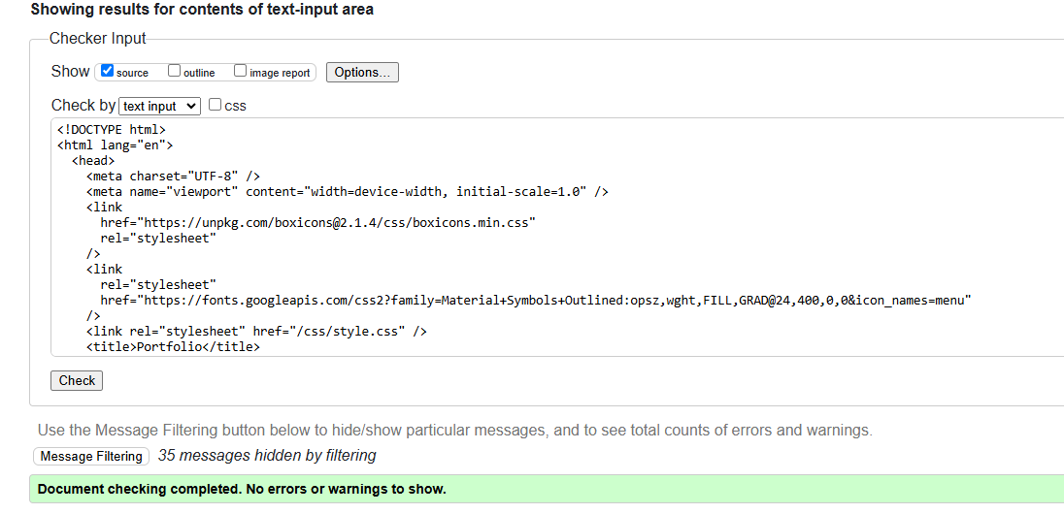
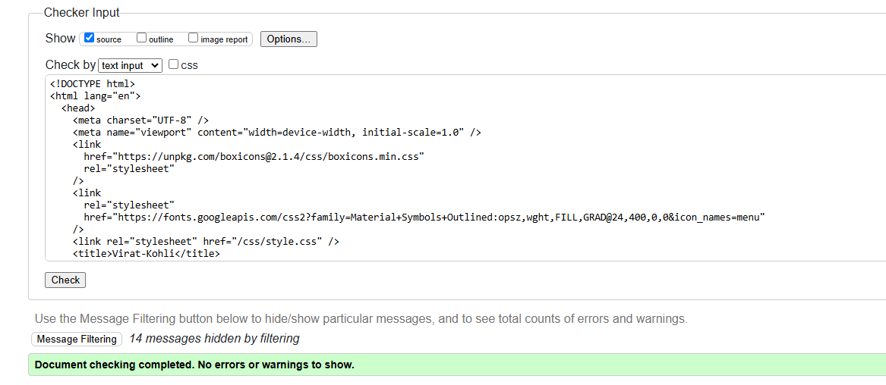
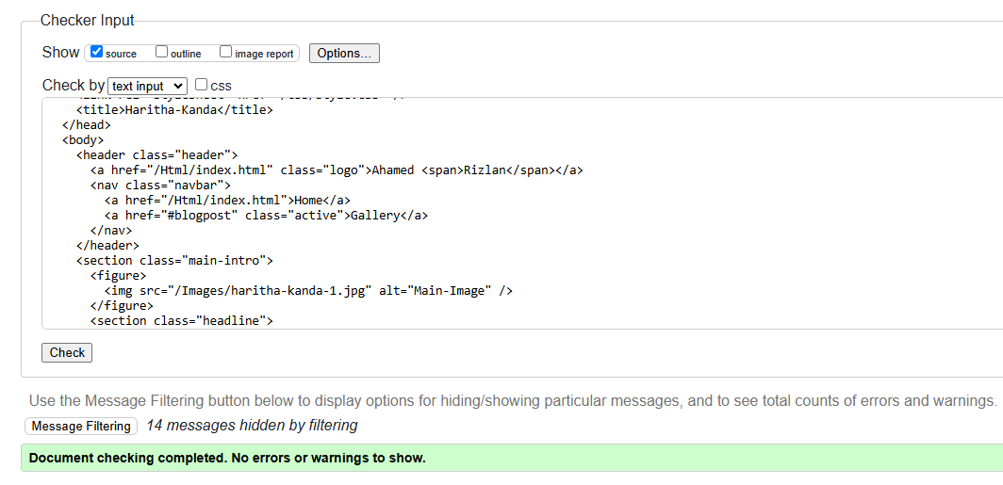

CSS LINT

FILE | RESULT
style.css | 4 Errors Shown, due to the validator not Being familiar with variables in CSS  Reference: https://www.w3schools.com/css/css3_variables.asp
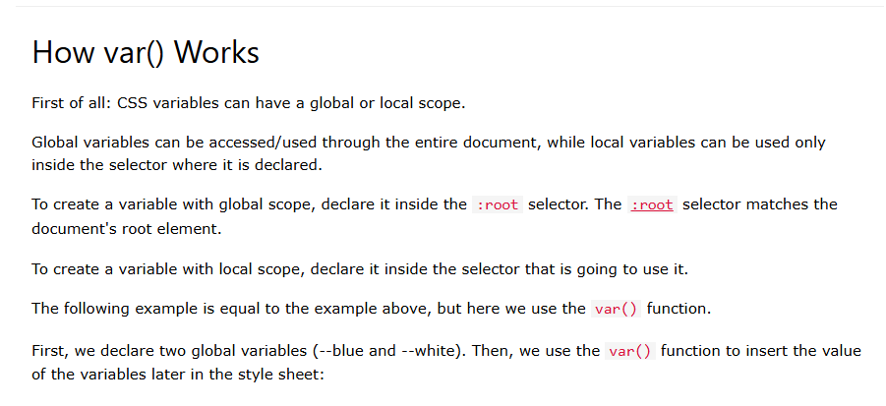
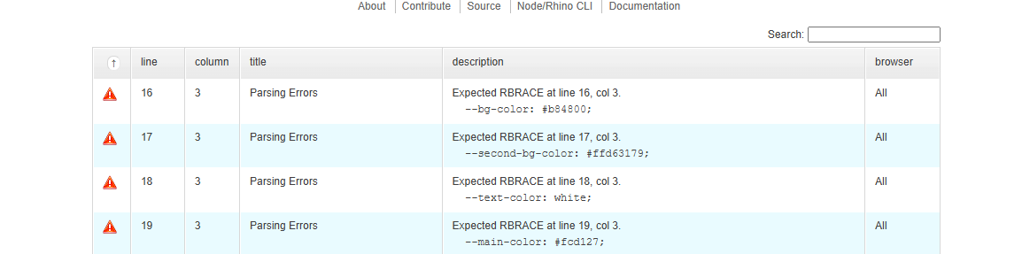
LAYOUTS

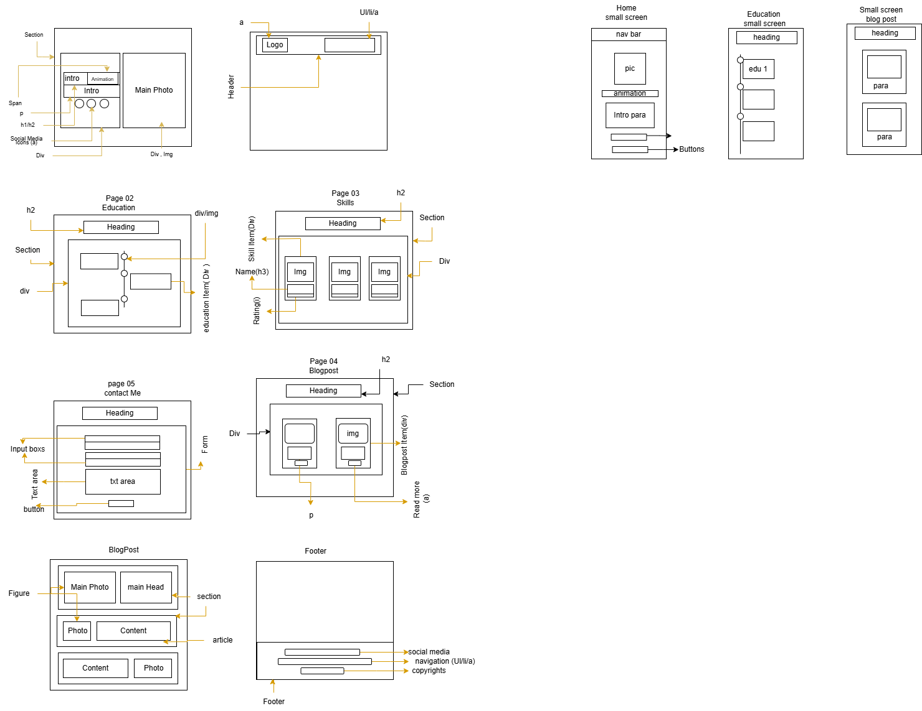

CODES

HTML FILES

index.HTML

<!DOCTYPE html>
<html lang="en">
<head>
<meta charset="UTF-8" />
<meta name="viewport" content="width=device-width, initial-scale=1.0" />
<link
href="https://unpkg.com/boxicons@2.1.4/css/boxicons.min.css"
rel="stylesheet"
/>
<link
rel="stylesheet"
href="https://fonts.googleapis.com/css2?family=Material+Symbols+Outlined:opsz,wght,FILL,GRAD@24,400,0,0&icon_names=menu"
/>
<link rel="stylesheet" href="/css/style.css" />
<title>Portfolio</title>
</head>
<body>
<header class="header">
<a href="#home" class="logo">Ahamed <span>Rizlan</span></a>
<nav class="navbar">
<a href="#home" class="active">Home </a>
<a href="#education">Education</a>
<a href="#superPowers">Skills</a>
<a href="#blogpost">Gallery</a>
<a href="#contact">Contact</a>
</nav>
</header>

<!--Section Home-->
<section class="home" id="home">
<div class="home-content">
<h1>Hi, It's <span>Rizlan</span></h1>
<h3 class="text-animation">I'm a <span></span></h3>
<p>
I'm an IT enthusiast passionate about leveraging technology for
innovative business solutions. As an Associate Application Consultant,
I thrive in dynamic environments, solving complex problems and
delivering impactful results. Outside of work, I enjoy playing
cricket, which enhances my teamwork and strategic thinking skills.
</p>
<div class="social-icons">
<a href="https://www.linkedin.com/in/rizlan-ahamed/"
><i class="bx bxl-linkedin"></i
></a>
<a href="https://github.com/Rizu2oo2"
><i class="bx bxl-github"></i
></a>
<a
href="https://www.instagram.com/ahd_rizlan/profilecard/?igsh=MWpyNGNhYmNzY3o1aA=="
><i class="bx bxl-instagram"></i
></a>
<a href="https://wa.me/qr/YJUB2BLZQYKCH1"
><i class="bx bxl-whatsapp"></i
></a>
</div>
<div class="btn-group">
<a href="#blogpost" class="btn">Gallery</a>
<a href="#contact" class="btn">Contact</a>
</div>
</div>
<div class="home-img">
<img src="/Images/Rizlan-removebg-preview.png" alt="Home Image" />
</div>
</section>

<!--Section Education-->
<section class="education" id="education">
<h2 class="heading">Education</h2>
<div class="timeline-items">
<!-- Education Content 1 -->
<div class="timeline-item">
<div class="timeline-dot">
<img src="/Images/KCK-logo.jpg" alt="Kck logo" />
</div>

<div class="timeline-date">
<time datetime="2008">2008</time> -
<time datetime="2021">2021/2022</time>
</div>
<div class="timeline-content">
<h2>School</h2>
<p>
I started my academic journey at
<span>Baduriya Central College Mawanella</span>, where I actively
participated in co-curricular activities and earned 7 A's and 2
B's in my O/Ls. Later, I pursued Bio Science at
<span>Kingswood College Kandy</span>, where involvement in clubs
like Interact and Islamic Majlis enriched my experience. I'm proud
of my A/L results of 2 C's and 1 S, reflecting a well-rounded
educational path.
</p>
</div>
</div>

<!-- Education Content 2 -->
<div class="timeline-item">
<div class="timeline-dot">
<img src="/Images/IIT-logo.png" alt="IIT logo" />
</div>
<div class="timeline-date">
<time datetime="2023">2023 - Present </time>
</div>
<div class="timeline-content">
<h2>University</h2>
<p>
I am currently pursuing a degree in
<span>Computer Science at IIT </span>under the Info-School
scholarship. This journey has allowed me to apply what I've
learned in practical, real-world settings. Balancing studies with
other commitments has been both challenging and deeply rewarding,
giving me the skills and experience I need to shape my future in
the IT field.
</p>
</div>
</div>

<!-- Education Content 3 -->
<div class="timeline-item">
<div class="timeline-dot">
<img src="/Images/Mitra-Logo.png" alt="mitra logo" />
</div>
<div class="timeline-date">
<time datetime="2022">2023 - Present</time>
</div>
<div class="timeline-content">
<h2>Internship</h2>
<p>
I am currently working as a Certification for Service Analysts at
<span>Mitra Innovations</span>, a role I have been in for the past
year. This position has allowed me to develop a deeper
understanding of IT service management and has given me the
opportunity to enhance my analytical and problem-solving skills in
a dynamic environment.
</p>
</div>
</div>

<!-- Education Content 4 -->
<div class="timeline-item">
<div class="timeline-dot">
<img src="/Images/creatio-logo.png" alt="mitra logo" />
</div>
<div class="timeline-date">
<time datetime="2023">2023 - Present</time>
</div>
<div class="timeline-content">
<h2>Creatio Analyst</h2>
<p>
As a <span>Creatio Analyst</span>, I specialize in the
functionalities of the Creatio platform, including no-code
customization and BPM tools. My certification is designed for
product owners, business analysts, presale engineers, and
technical consultants who work with the Creatio platform. This
expertise allows me to effectively tailor solutions and streamline
processes to meet diverse business needs.
</p>
</div>
</div>
</div>
</section>

<!--Section Skills-->
<section class="superPowers" id="superPowers">
<div class="superpower-container">
<h2 class="heading">Skills</h2>
<div class="superpower-items">
<!-- ---- Skill 1 ------ -->
<div class="superpower-item">
<img src="/Images/HTML.png" alt="html logo" />
<h2>HTML</h2>
<div class="rating">
<i class="bx bxs-star selected-Star"></i>
<i class="bx bxs-star selected-Star"></i>
<i class="bx bxs-star selected-Star"></i>
<i class="bx bxs-star selected-Star"></i>
<i class="bx bxs-star Star"></i>
</div>
</div>

<!-- ---- Skill 2 ------ -->
<div class="superpower-item">
<img src="/Images/CSS.png" alt="css logo" />
<h2>CSS</h2>
<div class="rating">
<i class="bx bxs-star selected-Star"></i>
<i class="bx bxs-star selected-Star"></i>
<i class="bx bxs-star selected-Star"></i>
<i class="bx bxs-star Star"></i>
<i class="bx bxs-star Star"></i>
</div>
</div>

<!-- ---- Skill 3 ------ -->
<div class="superpower-item">
<img src="/Images/python.png" alt="python logo" />
<h2>Python</h2>
<div class="rating">
<i class="bx bxs-star selected-Star"></i>
<i class="bx bxs-star selected-Star"></i>
<i class="bx bxs-star selected-Star"></i>
<i class="bx bxs-star selected-Star"></i>
<i class="bx bxs-star Star"></i>
</div>
</div>

<!-- ---- Skill 3 ------ -->
<div class="superpower-item">
<img src="/Images/java.png" alt="java logo" />
<h2>Java</h2>
<div class="rating">
<i class="bx bxs-star selected-Star"></i>
<i class="bx bxs-star selected-Star"></i>
<i class="bx bxs-star selected-Star"></i>
<i class="bx bxs-star selected-Star"></i>
<i class="bx bxs-star Star"></i>
</div>
</div>

<!-- ---- Skill 4 ------ -->
<div class="superpower-item">
<img src="/Images/C.png" alt="C#" />
<h2>C#</h2>
<div class="rating">
<i class="bx bxs-star selected-Star"></i>
<i class="bx bxs-star selected-Star"></i>
<i class="bx bxs-star selected-Star"></i>
<i class="bx bxs-star Star"></i>
<i class="bx bxs-star Star"></i>
</div>
</div>

<!-- ---- Skill 5 ------ -->
<div class="superpower-item">
<img src="/Images/mysql.png" alt="MySQL" />
<h2>MySQL</h2>
<div class="rating">
<i class="bx bxs-star selected-Star"></i>
<i class="bx bxs-star selected-Star"></i>
<i class="bx bxs-star selected-Star"></i>
<i class="bx bxs-star selected-Star"></i>
<i class="bx bxs-star Star"></i>
</div>
</div>

<!-- ---- Skill 6 ------ -->
<div class="superpower-item">
<img src="/Images/appian.png" alt="Appian" />
<h2>Appian</h2>
<div class="rating">
<i class="bx bxs-star selected-Star"></i>
<i class="bx bxs-star selected-Star"></i>
<i class="bx bxs-star selected-Star"></i>
<i class="bx bxs-star Star"></i>
<i class="bx bxs-star Star"></i>
</div>
</div>

<!-- ---- Skill 7 ------ -->
<div class="superpower-item">
<img src="/Images/creatio.png" alt="creatio" />
<h2>Creatio</h2>
<div class="rating">
<i class="bx bxs-star selected-Star"></i>
<i class="bx bxs-star selected-Star"></i>
<i class="bx bxs-star selected-Star"></i>
<i class="bx bxs-star selected-Star"></i>
<i class="bx bxs-star Star"></i>
</div>
</div>
</div>
</div>
</section>

<!--Section Blog-post-->
<section class="blogpost" id="blogpost">
<h2 class="heading">Gallery</h2>
<div class="blogpost-items">
<!-- -----blog post 1-------------- -->
<div class="blogpost-item">
<img src="/Images/Virath-main.jpg" alt="Virat-Kohli image" />
<h2>Icon Of Cricket</h2>
<p>
Virat Kohli, born November 5, 1988, is a legendary cricketer known
for his aggressive batting and leadership. Debuting for India in
2008, he quickly rose to captaincy, leading the team to many
victories. With a strong fitness regime and millions of fans,
Kohli's influence extends beyond cricket.
</p>
<a href="/Html/virat-Kohli.html" class="btn">Read More...</a>
</div>

<!-- -----blog post 2-------------- -->
<div class="blogpost-item">
<img
src="/Images/haritha-kanda-5.jpg"
alt="Haritha kanda main photo"
/>
<h2>Our Adventure to Haritha Kanda</h2>
<p>
Haritha Kanda, nestled in the Star of Sri Lanka, is a serene hilltop
destination known for its lush greenery, tranquil environment, and
breathtaking views. A hidden gem for nature lovers and adventurers
alike, it offers an escape into the peaceful embrace of nature, away
from the hustle and bustle of city life.
</p>
<a href="/Html/haritha-Kanda.html" class="btn">Read More...</a>
</div>
</div>
</section>

<!--Section Contact Me-->
<section class="contact" id="contact">
<h2 class="heading">Contact<span>Me</span></h2>
<form
action="mailto:rizlan.20223256@iit.ac.lk"
method="post"
enctype="text/plain"
>
<div class="input-group">
<div class="input-box">
<input
type="text"
placeholder="Full name"
name="Name"
pattern="[A-Za-z\s]"
title="Should only contain Alphabats"
required
/>
<input type="email" placeholder="Email" name="Email" required />
</div>
<div class="input-box">
<input
type="tel"
placeholder="Phone number"
name="Number"
maxlength="10"
pattern="[0-9]{10}"
title="Phone number should be 10 digits long"
required
/>
<input type="text" placeholder="Subject" name="Subject" required />
</div>
</div>
<div class="input-group-2">
<textarea
cols="30"
rows="10"
placeholder="your message"
name="Message"
required
></textarea>
<input type="submit" value="Send Message" class="btn" />
</div>
</form>
</section>
<!--Section Footer-->
<footer class="footer">
<div class="social-icons">
<a href="https://www.linkedin.com/in/rizlan-ahamed/"
><i class="bx bxl-linkedin"></i
></a>
<a href="https://github.com/Rizu2oo2"><i class="bx bxl-github"></i></a>
<a
href="https://www.instagram.com/ahd_rizlan/profilecard/?igsh=MWpyNGNhYmNzY3o1aA=="
><i class="bx bxl-instagram"></i
></a>
<a href="https://wa.me/qr/YJUB2BLZQYKCH1"
><i class="bx bxl-whatsapp"></i
></a>
</div>
<ul class="list">
<li>
<a href="#home">Home </a>
</li>
<li>
<a href="#education">Education </a>
</li>
<li>
<a href="#superPowers">Skills </a>
</li>
<li>
<a href="#blogpost">Gallery</a>
</li>
<li>
<a href="#contact" class="active"> Contact Me </a>
</li>
</ul>
<p class="copyrights">&copy; Ahamed Rizlan | All Rights Reserved</p>
</footer>
</body>
</html>

virat-Kohli.HTML

<!DOCTYPE html>
<html lang="en">
<head>
<meta charset="UTF-8" />
<meta name="viewport" content="width=device-width, initial-scale=1.0" />
<link
href="https://unpkg.com/boxicons@2.1.4/css/boxicons.min.css"
rel="stylesheet"
/>
<link
rel="stylesheet"
href="https://fonts.googleapis.com/css2?family=Material+Symbols+Outlined:opsz,wght,FILL,GRAD@24,400,0,0&icon_names=menu"
/>
<link rel="stylesheet" href="/css/style.css" />
<title>Virat-Kohli</title>
</head>
<body>
<header class="header">
<a href="/Html/index.html" class="logo">Ahamed <span>Rizlan</span></a>
<nav class="navbar">
<a href="/Html/index.html">Home</a>
<a href="#blogpost" class="active">Gallery</a>
</nav>
</header>
<section class="main-intro">
<figure>
<img src="/Images/vk-captain.jpg" alt="Main-Image" />
</figure>
<section class="headline">
<h1>Virat Kohli</h1>
<h2><span>G.O.A.T </span>of Cricket</h2>
</section>
</section>
<section class="blog-content">
<figure>
<figure>
<img src="/Images/Vk-teenage.jpg" alt="Teenage Kohli" />
</figure>
</figure>
<article>
<h2>The Modern Cricketing Icon</h2>
<p>
In the world of cricket, few names resonate as strongly as Virat
Kohli. Born on<time datetime="1988">1988</time>-11-5, in Delhi, India,
Kohli's journey from a young boy with a passion for cricket to one of
the most celebrated athletes in the sport is nothing short of
inspiring
</p>
<p>
Kohli's love for cricket blossomed at an early age. He joined the West
Delhi Cricket Academy and quickly showcased his talent, earning a spot
on the Indian U-19 team. His breakthrough came in
<time> 2008</time> when he made his ODI debut against Sri Lanka,
scoring an impressive 12 runs. It wasn't long before he became a
regular in the national team, thanks to his aggressive batting and
unwavering determination.
</p>
</article>
</section>
<section class="blog-content">
<figure>
<figure>
<img src="/Images/vk-in-RCB.jpeg" alt="Virat in RCB" />
</figure>
</figure>
<article>
<h2>Records and Achievements</h2>
<p>
Kohli's batting prowess is reflected in his record-breaking
achievements. He holds numerous records, including being one of the
<mark>
fastest players to score 8,000, 9,000, and 10,000 runs in
ODIs.</mark
>
His remarkable ability to chase down targets has earned him the
nickname <mark>"Chase Master."</mark> Kohli's aggressive style,
combined with his keen cricketing intelligence, has made him a
formidable opponent on the field.
</p>
<h2>Leadership</h2>
<p>
In 2017, Kohli took over as the captain of the Indian Test team,
leading with a blend of aggression and strategic thinking. Under his
captaincy, India achieved significant milestones, including a historic
Test series win in Australia in 2020-21. His leadership style
emphasizes fitness, discipline, and a relentless pursuit of
excellence.
</p>
</article>
</section>
<section class="blog-content">
<figure>
<figure>
<img src="/Images/vk-india.jpg" alt="Virath in Indian Jersy" />
</figure>
</figure>
<article>
<h2>Conclusion</h2>
<p>
Virat Kohli's journey from a passionate young cricketer to a
modern-day icon is a testament to his hard work, talent, and
determination. As he continues to break records and inspire the next
generation of cricketers, Kohli remains a true ambassador of the
sport, embodying the spirit of cricket both on and off the field.
</p>
</article>
</section>

<footer class="footer">
<div class="social-icons">
<a href="https://www.linkedin.com/in/rizlan-ahamed/"
><i class="bx bxl-linkedin"></i
></a>
<a href="https://github.com/Rizu2oo2"><i class="bx bxl-github"></i></a>
<a
href="https://www.instagram.com/ahd_rizlan/profilecard/?igsh=MWpyNGNhYmNzY3o1aA=="
><i class="bx bxl-instagram"></i
></a>
<a href="https://wa.me/qr/YJUB2BLZQYKCH1"
><i class="bx bxl-whatsapp"></i
></a>
</div>
<ul class="list">
<li>
<a href="index.html">Home</a>
</li>
<li>
<a href="#blogpost" class="active">Gallery</a>
</li>
</ul>
<p class="copyrights">&copy; Ahamed Rizlan | All Rights Reserved</p>
</footer>
</body>
</html>

haritha-Kanda.HTML
<!DOCTYPE html>
<html lang="en">
<head>
<meta charset="UTF-8" />
<meta name="viewport" content="width=device-width, initial-scale=1.0" />
<link
href="https://unpkg.com/boxicons@2.1.4/css/boxicons.min.css"
rel="stylesheet"
/>
<link
rel="stylesheet"
href="https://fonts.googleapis.com/css2?family=Material+Symbols+Outlined:opsz,wght,FILL,GRAD@24,400,0,0&icon_names=menu"
/>
<link rel="stylesheet" href="/css/style.css" />
<title>Haritha-Kanda</title>
</head>
<body>
<header class="header">
<a href="/Html/index.html" class="logo">Ahamed <span>Rizlan</span></a>
<nav class="navbar">
<a href="/Html/index.html">Home</a>
<a href="#blogpost" class="active">Gallery</a>
</nav>
</header>
<section class="main-intro">
<figure>
<img src="/Images/haritha-kanda-1.jpg" alt="Main-Image" />
</figure>
<section class="headline">
<h1>Haritha Kanda</h1>
<h2>The <span>Green Mountain</span></h2>
</section>
</section>
<section class="blog-content">
<figure>
<img src="/Images/haritha-kanda-2.jpg" alt="Insect" />
</figure>
<article>
<h2>The Ride Through Paradise</h2>
<p>
A few weeks ago, six of us, armed with our adventurous spirits, set
out on a journey from Kandy to Bogawantalawa on three bikes. The plan
was simple: enjoy the ride, camp under the stars, and explore the
beauty of Haritha Kanda. We packed our tents, got police permission
for the campsite, and hit the road, ready for an experience that none
of us would forget.
</p>
<p>
The moment we left Kandy, we knew we were in for a scenic treat. The
road itself felt like a journey through a natural painting. As we rode
along the winding roads, the views became more and more surreal. We
passed lush green valleys, tea estates that stretched endlessly, and
mist-covered mountains in the distance. The early morning sun bathed
everything in a golden glow, making the trees shimmer and the air feel
crisp. There were times when we had to slow down just to take it all
in - the fresh air, the cool breeze, and the serene landscape were a
welcome break from our usual hustle in the city.
</p>
</article>
</section>
<section class="blog-content">
<figure>
<img src="/Images/haritha-kanda-3.jpg" alt="Haritha View" />
</figure>
<article>
<h2>Climbing Into Bogawantalawa</h2>
<p>
As we neared Bogawantalawa, also known as the
<mark>"Golden Valley of Tea,"</mark>
the views only got better. The sea of tea plantations, spread out like
a green carpet, was absolutely breathtaking. With each twist and turn
in the road, we were met with views of cascading hills covered in tea
bushes, with small villages dotted along the way. We stopped multiple
times just to click photos and take short breaks, gazing at the neatly
lined tea plants, with the distant mountains playing hide and seek
with the clouds. It felt like we were riding through a postcard.
</p>
<h2>Setting Up Camp at Haritha Kanda</h2>
<p>
Once we reached Bogawantalawa, we headed to our chosen campsite at
Haritha Kanda. After getting the necessary permission from the local
police, we began setting up our tents. It was an ideal spot - slightly
elevated, giving us a panoramic view of the valley below. The sun was
starting to set, casting a warm glow over the hills, and we knew we
were in for a beautiful night. As darkness fell, the stars came out in
full force. We sat around, telling stories, laughing, and enjoying the
calm that enveloped us. It was the kind of peace you rarely find in
day-to-day life. No phone signals, no distractions - just us, the
crackling of our campfire, and the sound of nature.
</p>
</article>
</section>
<section class="blog-content">
<figure>
<img src="/Images/haritha-kanda-4.jpg" alt="Pic of mine" />
</figure>
<article>
<h2>The Morning After: A Sunrise to Remember</h2>
<p>
Waking up the next morning was nothing short of magical. The mist had
rolled in overnight, and as the sun slowly rose, it began to burn it
away, revealing the green landscape beneath. The cool morning air was
filled with the scent of fresh tea leaves, and the view of the sun
rising over the mountains was the perfect way to start the day. We
brewed some tea, packed up our tents, and got ready to head back. But
none of us were really ready to leave. Haritha Kanda had cast its
spell on us, and the ride back was filled with conversations about
when we'd come back again.
</p>
<h2>Until Next Time</h2>
<p>
This trip was more than just a getaway - it was a reminder of how
beautiful and peaceful the world can be if you just take the time to
explore it. Riding with friends, camping under the stars, and
experiencing the raw beauty of Haritha Kanda was an adventure none of
us will ever forget. We'll definitely be back. But for now, the
memories we made will keep us company until the next trip.
</p>
</article>
</section>

<footer class="footer">
<div class="social-icons">
<a href="https://www.linkedin.com/in/rizlan-ahamed/"
><i class="bx bxl-linkedin"></i
></a>
<a href="https://github.com/Rizu2oo2"><i class="bx bxl-github"></i></a>
<a
href="https://www.instagram.com/ahd_rizlan/profilecard/?igsh=MWpyNGNhYmNzY3o1aA=="
><i class="bx bxl-instagram"></i
></a>
<a href="https://wa.me/qr/YJUB2BLZQYKCH1"
><i class="bx bxl-whatsapp"></i
></a>
</div>
<ul class="list">
<li>
<a href="index.html">Home</a>
</li>
<li>
<a href="#blogpost" class="active">Gallery</a>
</li>
</ul>
<p class="copyrights">&copy; Ahamed Rizlan | All Rights Reserved</p>
</footer>
</body>
</html>

CSS FILES

style.css

/* removing preset or default styles */
* {
margin: 0%;
padding: 0%;
box-sizing: border-box;
/* to ensure that padding and border widths are included in the element's total width and height*/
text-decoration: none;
border: none;
outline: none;
font-family: "poppins", sans-serif;
/* mentioning the font family */
}

/* Pre Assaiging colors */
:root {
--bg-color: #b84800;
--second-bg-color: #ffd63179;
--text-color: white;
--main-color: #fcd127;
}

/* ---------common css----------------- */
/* rem- define the sizes relative to font size set on root elemant */
html {
font-size: 80%;
/* having font size in % so can adust as needed */
width: 100vw;
overflow-x: hidden;
}
body {
background-color: var(--bg-color);
color: var(--text-color);
}
span {
color: var(--main-color);
}
section {
margin: 2%;
padding: 3%;
}
.heading {
font-size: 6rem;
text-align: center;
margin: 5% 0;
}
/* scroll bar */
::-webkit-scrollbar {
width: 5px;
}
::-webkit-scrollbar-track {
background-color: var(--bg-color);
height: 80%;
}
::-webkit-scrollbar-thumb {
background-color: var(--main-color);
box-shadow: 0 0 10px var(--bg-color) inset;
border-radius: 20%;
}
::-webkit-scrollbar-thumb:hover {
box-shadow: 0 0 10px var(--main-color);
}
/* make header nonsticky since we wont use js */
/* -------header and navbar---------------- */
.header {
display: flex;
flex-direction: row;
background: rgba(0, 0, 0, 0.3);
align-content: center;
justify-content: space-between;
align-items: center;
position: relative;
width: 100vw;
padding: 2%;
}
.navbar {
display: flex;
margin: 0 6%;
padding: 0, 2%;
}
.navbar a {
font-size: 1.5rem;
color: var(--text-color);
margin: 0 0 5% 4%;
padding: 0 10px;
font-weight: 700;
transition: 0.3 ease-in-out;
}
.navbar a.active {
color: var(--main-color);
border-bottom: 3px solid var(--main-color);
text-shadow: 0 0 3rem var(--main-color);
}

.navbar a:hover {
color: var(--main-color);
text-shadow: 0 0 3rem var(--main-color);
transform: scale(1.05);
}
.logo {
font-size: 2.5rem;
color: var(--text-color);
font-weight: 800;
cursor: pointer;
transition: 0.3s ease-in-out;
}
.logo:hover {
transform: scale(1.1);
}
.logo span {
text-shadow: 0 0 3rem var(--main-color);
}
/*
-----------------main Intro Page---------------- */

.home {
display: flex;
align-items: center;
gap: 5%;
}
.home-content {
display: flex;
flex-direction: column;
align-items: flex-start;
text-align: left;
margin: 5%;
width: 100%;
}
.home-content h1 {
font-size: 5rem;
font-weight: 800;
line-height: 6rem;
}
.home-content h3 {
font-size: 3rem;
line-height: 4rem;
font-weight: 900;
margin: 1rem 0 2rem 0;
}
.home-img {
border-radius: 50%;
width: 100%;
}

.home-img img {
position: relative;
border-radius: 50%;
top: 5%;
width: 40rem;
box-shadow: 0 0 25px var(--main-color);
cursor: pointer;
transition: 0.9s ease-in-out;
background: linear-gradient(
to bottom,
var(--bg-color),
var(--second-bg-color)
);
}
.home-img :hover {
transform: scale(1.05);
border: none;
box-shadow: 0 0 75px var(--main-color);
}
.home-content p {
margin-top: 2%;
font-size: 1.5rem;
font-weight: 500;
line-height: 2rem;
}
.social-icons a {
display: inline-flex;
justify-content: center;
align-items: center;
height: 4.5rem;
width: 4.5rem;
background: transparent;
font-size: 3rem;
border-radius: 50%;
border: 2px solid var(--main-color);
color: var(--main-color);
margin: 2rem 1rem 3rem 0;
transition: 0.3s ease-in-out;
}
.social-icons a:hover {
color: var(--text-color);
transform: scale(1.05) translateY(-1rem);
background-color: var(--main-color);
box-shadow: 0 0 25px var(--main-color);
}
.btn-group {
display: flex;
align-items: center;
gap: 1.5rem;
}

.btn {
display: inline-block;
padding: 1rem 2rem;
font-size: 1.5rem;
border-radius: 2rem;
font-weight: 700;
letter-spacing: 0.1rem;
border: 2px solid transparent;
transition: 0.4s ease-in-out;
cursor: pointer;
color: var(--bg-color);
background: var(--main-color);
box-shadow: 0 0 25px var(--main-color);
}
.btn:hover {
transform: scale(1.05);
box-shadow: 0 0 50px var(--main-color);
}
.btn-group :nth-last-of-type(2) {
background-color: var(--bg-color);
color: var(--main-color);
border: 2px solid var(--main-color);
box-shadow: 0 0 25px var(--bg-color);
}
.btn-group :nth-last-of-type(2):hover {
box-shadow: var(--main-color);
background-color: var(--main-color);
color: var(--bg-color);
}
/* ----------------------text animation related css------------- */
.text-animation {
font-size: 4rem;
font-weight: 600;
line-height: 5rem;
}
.text-animation span {
position: relative;
}
.text-animation span::before {
animation: words 5s infinite;
content: "Application Consultant";
}

@keyframes words {
0%,
20% {
content: "Web Developer";
}
21%,
40% {
content: "Mobile Photographer";
}
41%,
60% {
content: "Full-Stack Developer";
}
61%,
80% {
content: "Creatio Developer";
}
}

/* ----------------------education page related Css--------------- */

.education {
background-color: var(--second-bg-color);
margin: 0%;
padding: 5%;
align-items: center;
justify-items: center;
}

.education h2 {
margin-bottom: 2%;
}
.timeline-items {
display: flex;
flex-wrap: wrap;
position: relative;
max-width: 80%;
margin: 2%;
}
.timeline-items::before {
content: "";
position: absolute;
background-color: var(--main-color);
width: 8px;
height: 100%;
left: calc(50%);
opacity: 0.7;
}

.timeline-item {
position: relative;
margin-top: 5%;
width: 100%;
}
.timeline-item:last-child {
margin-bottom: 5%;
}
.timeline-item:nth-child(odd) {
padding-right: calc(50% + 30px);
text-align: right;
/* aligning items to right */
}
.timeline-item:nth-child(even) {
padding-left: calc(50% + 30px);
text-align: left;
/* aligning items to left */
}
.timeline-dot img {
position: absolute;
left: calc(50% - 23px);
width: 4rem;
height: 4rem;
border-radius: 50%;
top: -10%;
transition: 0.4s ease-in-out;
}
.timeline-dot img:hover {
box-shadow: 0 0 25px var(--main-color);
transform: scale(1.3);
}
.timeline-date {
font-size: 2rem;
font-weight: 700;
color: var(--text-color);
margin: 1% 2%;
}
.timeline-content {
background-color: var(--bg-color);
border: 3px solid var(--main-color);
padding: 5%;
border-radius: 2rem;
box-shadow: 0 0 25px var(--main-color);
transition: 0.3s ease-in-out;
cursor: pointer;
}
.timeline-content:hover {
transform: scale(1.05);
}
.timeline-content > h2 {
font-size: 2rem;
font-weight: 700;
color: var(--main-color);
margin: 0 0 2%;
}
.timeline-content > P {
color: var(--text-color);
font-size: 1.2rem;
line-height: 1.5rem;
font-weight: 500;
}

/* -------------------------Skills ------------------- */

.superpower-items {
display: flex;
flex-wrap: wrap;
gap: 5%;
padding: 0 10%;
justify-content: center;
align-items: center;
}
.superpower-container img {
height: 15rem;
width: 15rem;
border-radius: 50%;
border: 2px solid var(--main-color);
box-shadow: 0 0 25px var(--main-color);
padding: 10%;
}
.superpower-item {
display: flex;
flex-direction: column;
text-align: center;
align-items: center;
justify-content: center;
margin: 2%;
background-color: var(--second-bg-color);
border: 3px solid var(--main-color);
color: var(--bg-color);
transition: 0.4s ease-in-out;
border-radius: 2rem;
padding: 1% 2%;
cursor: pointer;
}
.superpower-item:hover {
transform: scale(1.05);
box-shadow: 0 0 25px var(--main-color);
}
.superpower-item h2 {
font-size: 2rem;
margin-top: 10%;
margin-bottom: 2%;
}
.rating > .selected-Star {
color: var(--bg-color);
font-size: 2rem;
}

.rating > .Star {
display: none;
}

/* ----------------------------blogPost Page ---------------- */

.blogpost {
background-color: var(--second-bg-color);
margin: 0%;
}

.blogpost-items {
display: flex;
gap: 10%;
padding: 5%;
justify-content: center;
align-items: center;
}
.blogpost-item {
display: flex;
flex-wrap: wrap;
flex-direction: column;
align-items: center;
text-align: center;
border-radius: 2rem;
border: 2px solid var(--main-color);
background-color: var(--second-bg-color);
padding: 2% 1%;
width: 50%;
}
.blogpost-item:hover {
box-shadow: 0 0 25px var(--main-color);
}
.blogpost img {
width: 80%;
height: 25rem;
border-radius: 2rem;
}
.blogpost-item h2 {
margin: 2% 0;
font-size: 2rem;
line-height: 3rem;
color: var(--bg-color);
}
.blogpost-item p {
margin-bottom: 2rem;
font-size: 1.5rem;
line-height: 2rem;
font-weight: 700;
color: var(--text-color);
}

/* -----------------Contact Form---------------------------- */

.contact form {
display: flex;
flex-direction: column;
gap: 3rem;
text-align: center;
align-items: center;
justify-content: center;
}
.contact form .input-box {
display: flex;
flex-wrap: wrap;
justify-content: center;
}
.contact form .input-box input,
.contact form textarea {
width: 100%;
padding: 5%;
font-size: 1.5rem;
font-weight: 400;
border-radius: 2rem;
border: 2px solid var(--main-color);
background-color: var(--bg-color);
color: var(--main-color);
margin: 1rem;
resize: none;
}
.contact form textarea {
width: 90%;
}
.contact form .input-box input::placeholder,
.contact form textarea::placeholder {
color: var(--text-color);
font-weight: 700;
}
.contact form .btn {
margin-top: 2rem;
}

.contact form input:valid,
.contact form textarea:valid {
border-color: green;
}
.contact form input[type="submit"] {
border-color: var(--bg-color);
}

/*-------------------------Footer--------------------- */
.footer {
position: relative;
bottom: 0%;
width: 100vw;
padding: 2% 0;
background: rgba(0, 0, 0, 0.3);
}
.footer .social-icons {
text-align: center;
padding-bottom: 0%;
color: var(--main-color);
}
.footer .social-icons a {
display: inline-flex;
justify-content: center;
align-items: center;
height: 4.5rem;
width: 4.5rem;
background: transparent;
font-size: 3rem;
border-radius: 50%;
border: 2px solid var(--main-color);
color: var(--main-color);
margin: 2rem 1rem 3rem 0;
transition: 0.3s ease-in-out;
}
.footer .social-icons a:hover {
color: var(--text-color);
transform: scale(1.05) translateY(-1rem);
background-color: var(--main-color);
box-shadow: 0 0 25px var(--main-color);
}

.footer ul {
margin: 0%;
padding: 0%;
font-size: 1.5rem;
line-height: 2rem;
text-align: center;
transition: 0.3s ease-in-out;
}
.footer ul li a {
color: var(--text-color);
border-bottom: 3px solid transparent;
transition: 0.3s ease-in-out;
}
.footer ul li {
display: inline-block;
padding: 0 2%;
}
.footer ul li a.active {
border-bottom: 3px solid var(--main-color);
color: var(--main-color);
text-shadow: 0 0 25px var(--main-color);
}
.footer ul :hover {
color: var(--main-color);
text-shadow: 0 0 25px var(--main-color);
transform: translateY(-10px) scale(1.05);
}
.footer .copyrights {
margin-top: 3%;
text-align: center;
font-size: 1rem;
color: var(--text-color);
}

/* ---------------------------Blogpost Page---------------------- */

.main-intro {
display: flex;
align-items: center;
justify-items: center;
padding: 2%;
width: 100vw;
}

/* making both contents equally distributed so can manage the photot size */

.headline {
width: 50%;
}
figure {
display: flex;
align-items: center;
align-content: center;
justify-content: center;
justify-items: center;
width: 100%;
}
.main-intro img,
.blog-content img {
width: 50%;
border-radius: 2rem;
}
.headline h1 {
font-size: 3rem;
line-height: 4rem;
}
.headline h2 {
font-size: 2rem;
line-height: 3rem;
}
.blog-content {
display: flex;
}
.blog-content:nth-child(odd) {
flex-direction: row-reverse;
background-color: var(--second-bg-color);
margin: 0;
}

article {
width: 100%;
display: flex;
flex-wrap: wrap;
align-content: center;
justify-content: center;
padding: 0 2%;
}
article h2 {
font-size: 2rem;
line-height: 3rem;
color: var(--main-color);
padding: 2% 0;
font-weight: 700;
}

article p {
font-size: 1.5rem;
line-height: 2rem;
color: var(--text-color);
font-weight: 600;
text-align: justify;
}
.blog-content mark {
background-color: transparent;
color: var(--main-color);
font-weight: 800;
}
@media screen and (max-width: 1200px) {
html {
font-size: 50%;
width: 100vw;
overflow-x: hidden;
}
.blogpost-items {
display: flex;
flex-wrap: wrap;
}
.timeline-items::before {
width: 0.5%;
}
.blogpost-item {
display: flex;
flex-wrap: wrap;
padding: 2% 1%;
width: 50%;
margin-bottom: 3%;
}

.blogpost img {
width: 90%;
height: 30rem;
border-radius: 2rem;
}
.timeline-dot img {
left: calc(50% - 15px);
}
}

@media screen and (max-width: 725px) {
html {
font-size: 50%;
width: 100vw;
overflow-x: hidden;
}
.home {
display: flex;
flex-wrap: wrap;
flex-direction: column-reverse;
}
.home-img {
display: flex;
justify-content: center;
}
.home-content {
display: flex;
align-items: center;
}
.header {
width: 100vw;
align-items: center;
align-content: center;
justify-content: space-between;
}
.navbar {
display: flex;
flex-direction: row;
padding-right: 5px;
}
.navbar a.active {
border-bottom: 1px solid var(--main-color);
}
.footer ul li a.active {
border-bottom: 1px solid var(--main-color);
}
.timeline-items::before {
left: 2%;
width: 1%;
}
.timeline-item:nth-child(odd) {
padding-right: 0;
text-align: left;
}
.timeline-item:nth-child(even) {
padding-left: 0;
text-align: left;
}
.timeline-dot img {
left: 0;
}
.timeline-content {
margin-right: 0%;
margin-left: 10%;
}
.timeline-date {
margin-left: 10%;
margin-bottom: 5%;
}
}

@media screen and (max-width: 650px) {
html {
font-size: 40%;
width: 100vw;
overflow-x: hidden;
}
.home {
display: flex;
flex-wrap: wrap;
flex-direction: column-reverse;
}
.home-img {
display: flex;
justify-content: center;
}
.home-content {
display: flex;
align-items: center;
}
.header {
width: 100vw;
align-items: center;
align-content: center;
justify-content: space-between;
}
.navbar {
display: flex;
flex-direction: row;
padding-right: 10px;
}
.navbar a.active {
border-bottom: 1px solid var(--main-color);
}
.footer ul li a.active {
border-bottom: 1px solid var(--main-color);
}
.timeline-items::before {
left: 2%;
width: 1%;
}
.timeline-item:nth-child(odd) {
padding-right: 0;
text-align: left;
}
.timeline-item:nth-child(even) {
padding-left: 0;
text-align: left;
}
.timeline-dot img {
left: -1%;
}
.timeline-content {
margin-right: 0%;
margin-left: 10%;
}
.timeline-date {
margin-left: 10%;
margin-bottom: 5%;
}
}
@media screen and (max-width: 480px) {
html {
font-size: 30%;
overflow-x: hidden;
}

.home {
display: flex;
flex-wrap: wrap;
flex-direction: column-reverse;
}
.home-img {
display: flex;
justify-content: center;
}
.home-content {
display: flex;
align-items: center;
}
.header {
width: 100%;
align-items: center;
align-content: center;
justify-content: space-between;
}
}

SCREENSHOTS OF FINAL WEBSITE

DESKTOP VIEW
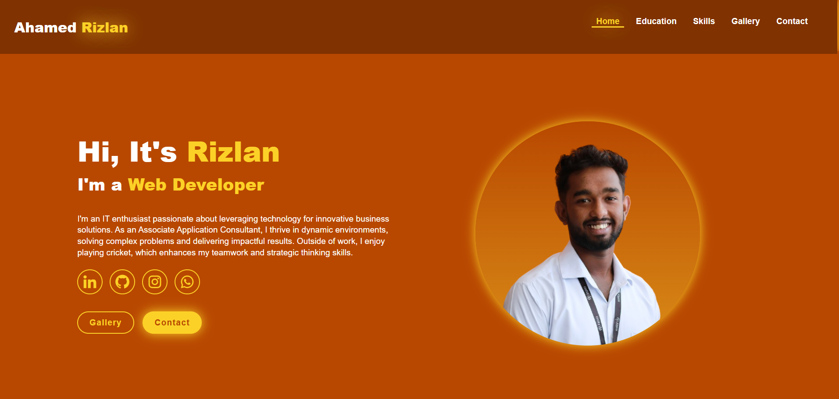
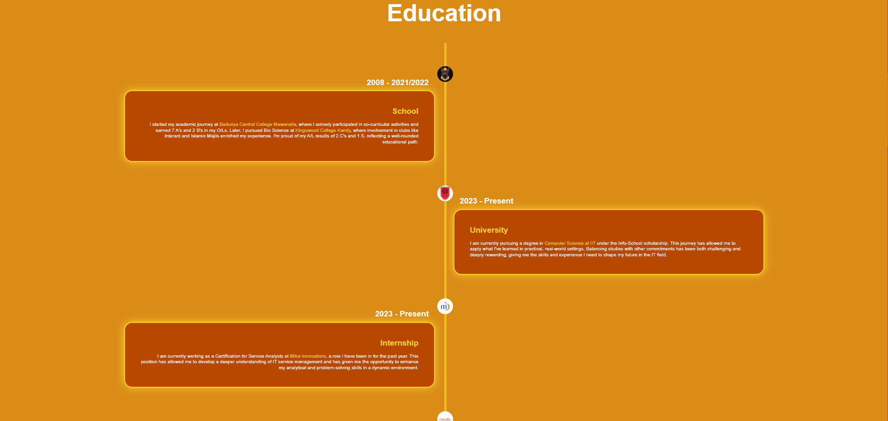

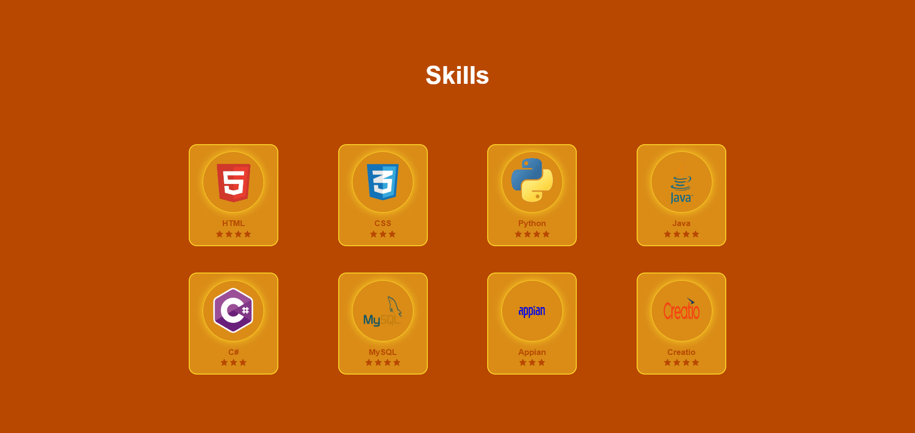
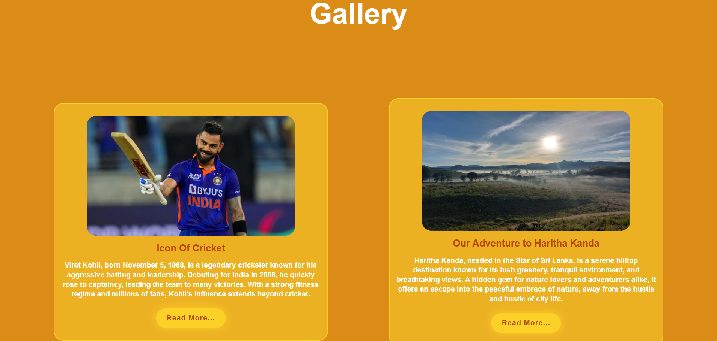
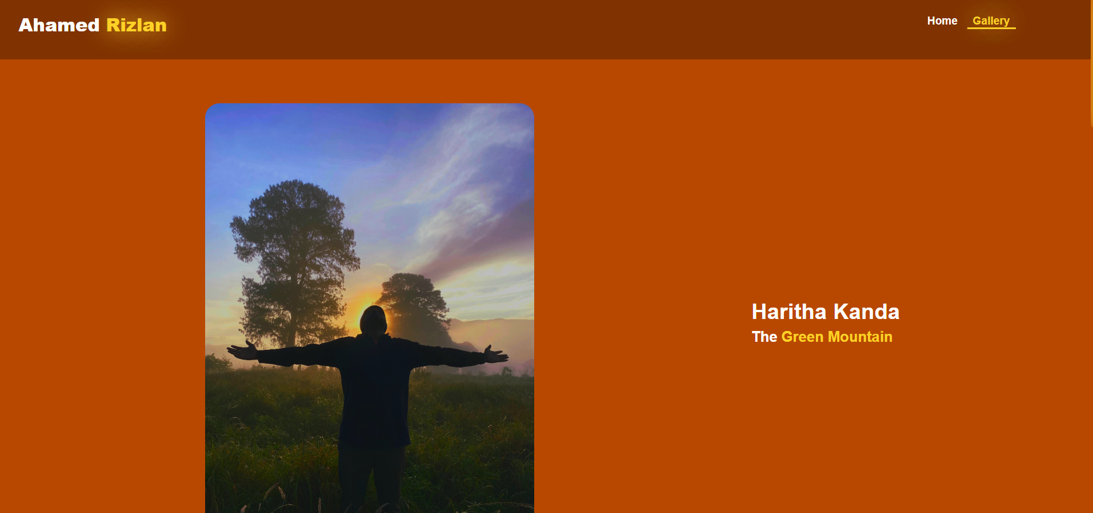
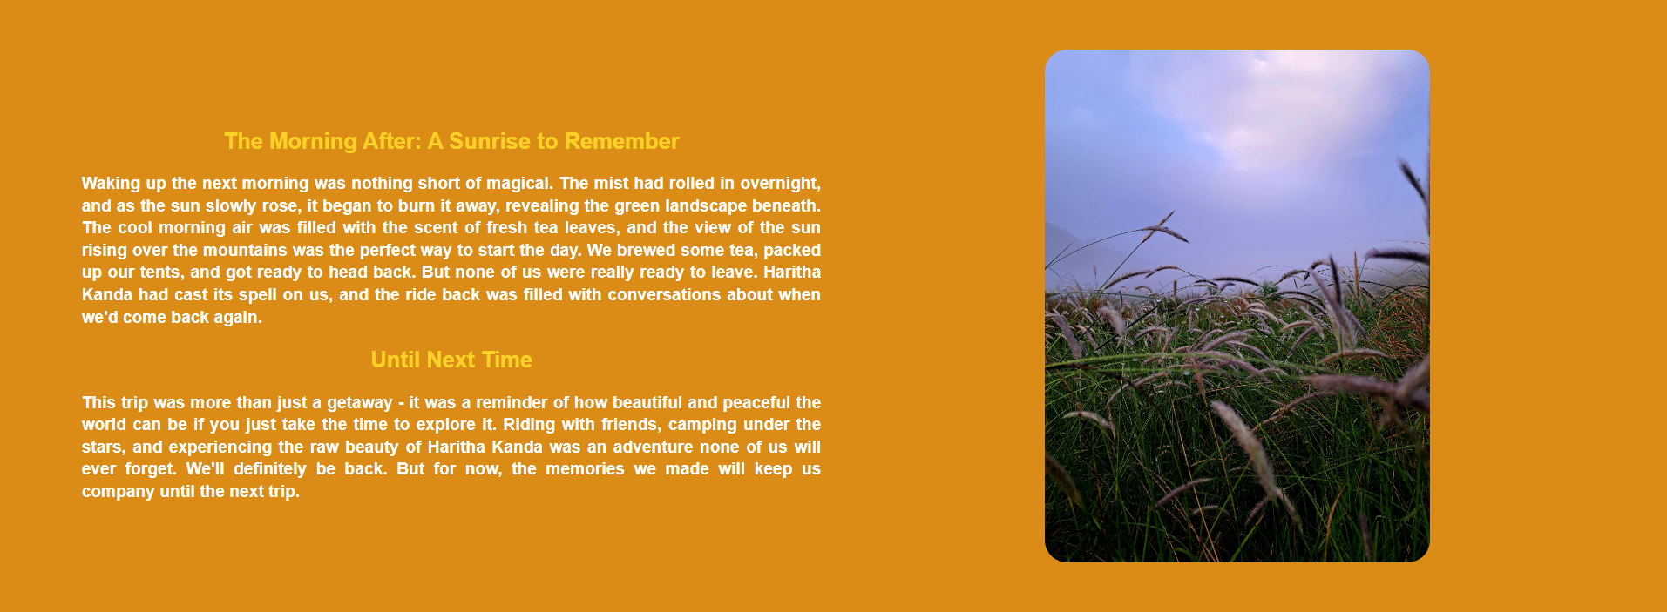

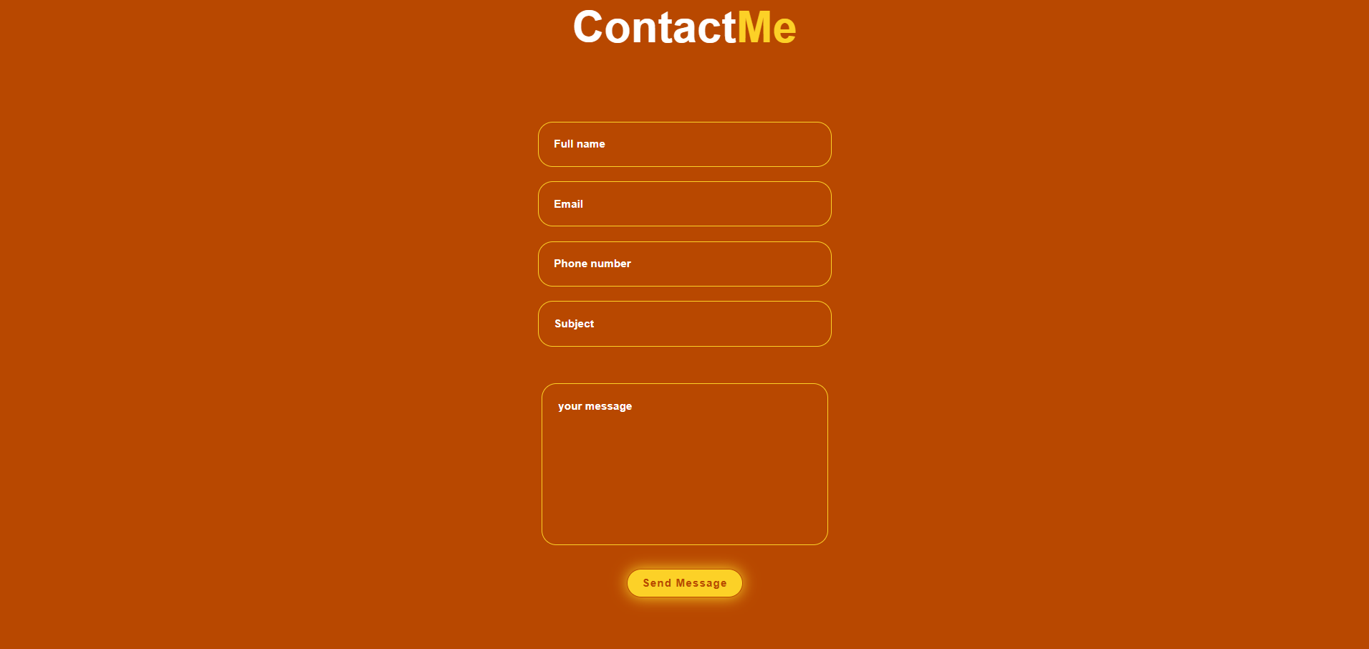



MOBILE VIEW
